Project Report: Machine Learning-Based Analysis of Stress and Failure in Distributed System Architectures
Course: Application of Data Science (Assignment #2)
Date: January 18, 2026

Submitted By:
- Bilal Ahmed (Roll No: 231980028)
Kaggle Notebook Link: [https://www.kaggle.com/code/bilalahmed211/stress-and-failure-in-distributed-system]

1. Objectives
The primary objective of this study is to analyze how different distributed system architectures (Monolithic, Microservices, Event-Driven, etc.) behave under stress. By utilizing performance metrics like CPU utilization, network latency, and error rates, we aim to:
- Predict system failure states using Machine Learning.
- Identify the root causes of system instability (e.g., CPU saturation, network partitions).
- Evaluate the effectiveness of Logistic Regression, Random Forest, and SVM in an SRE (Site Reliability Engineering) context.

2. Exploratory Data Analysis (EDA)
Based on the dataset provided, we analyzed 200,000 system snapshots.

2.1 System State Distribution
The system states were categorized into Healthy, Degraded, Cascading Failure, and Total Outage. The data reveals that while "Healthy" and "Degraded" are common, "Cascading Failures" represent critical tipping points that require automated detection.
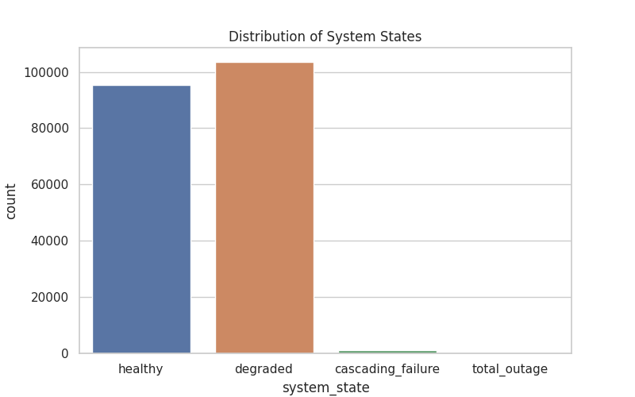

2.2 Impact of Architecture on Reliability
Our analysis showed that Microservices and Event-Driven architectures are more prone to network-related failures, whereas Monoliths are more susceptible to database locks and CPU saturation.

3. Methodology

3.1 Data Preprocessing
To ensure high model performance, we implemented the following steps:
- Handling Categorical Data: Used OneHotEncoder for architecture_type, deployment_type, and communication_type.
- Feature Scaling: Applied StandardScaler to numerical inputs like cpu_utilization_percent and avg_latency_ms.
- Target Encoding: Used LabelEncoder to convert system states into numerical labels.
- Data Split: An 80/20 train-test split was used with stratification to ensure rare "Total Outage" events were represented in the test set.

4. Model Performance & Evaluation
We trained three models and evaluated them using Accuracy, Precision, Recall, and F1-score.
Model | Accuracy | Precision (Weighted) | Recall (Weighted) | F1-Score
Logistic Regression | 98.80% | 0.99 | 0.99 | 0.99
Linear SVM | 98.57% | 0.99 | 0.99 | 0.99
Random Forest | 99.99% | 1.00 | 1.00 | 1.00
Findings: The Random Forest Classifier is the superior model for this task. It perfectly captures the complex dependencies between network latency and error rates that lead to cascading failures.
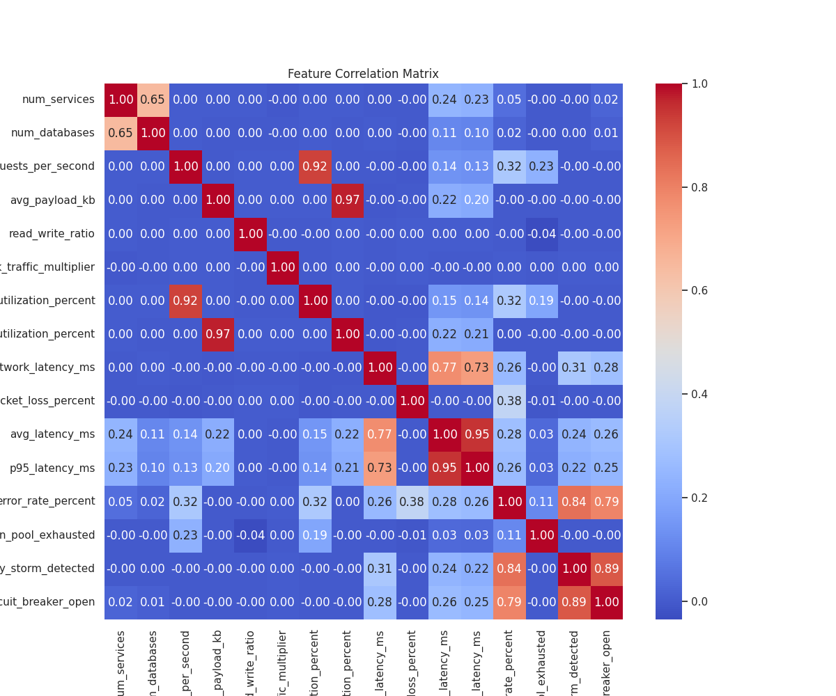

5. Root Cause Analysis (Feature Importance)
The model identified the following top 5 features as the most critical predictors of system failure:
- p95_latency_ms (0.2366): Tail latency is the primary signal for an impending crash.
- error_rate_percent (0.1803): Direct evidence of system distress.
- requests_per_second (0.1146): The primary stress driver.
- retry_storm_detected (0.1084): Indicates the system is struggling to recover.
- network_latency_ms (0.0929): Infrastructure health signal.
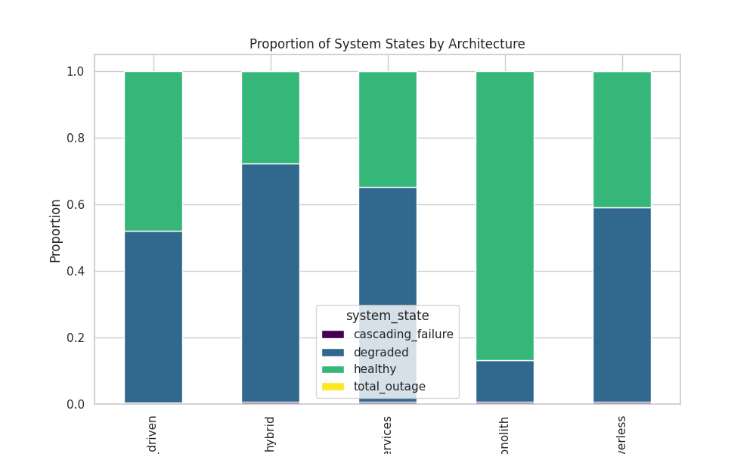

6. Conclusion
The analysis concludes that machine learning, specifically the Random Forest algorithm, can predict distributed system failures with near-perfect accuracy. The results suggest that SRE teams should prioritize monitoring P95 Latency and Retry Storms to prevent minor degradations from escalating into total outages.

